**Course One**

# Foundations of Data Science



# Instructions

Use this PACE strategy document to record decisions and reflections as you work through this end-of-course project. You can use this document as a guide to consider your responses and reflections at different stages of the data analytical process. Additionally, the PACE strategy documents can be used as a resource when working on future projects.

# Course Project Recap

Regardless of which track you have chosen to complete, your goals for this project are:

* Complete the PACE Strategy Document to plan your project while considering your audience members, teammates, key milestones, and overall project goal.
* Create a project proposal for the data team.

# Relevant Interview Questions

Completing this end-of-course project will empower you to respond to the following interview topics:

* As a new member of a data analytics team, what steps could you take to get 'up to speed' with a current project? What steps would you take? Who would you like to meet with?
* How would you plan an analytics project?
* What steps would you take to translate a business question to an analytical solution?
* Why is actively managing data an important part of a data analytics team's responsibilities?
* What are some considerations you might need to be mindful of when reporting results?

**Reference Guide**

This project has three tasks; the following visual identifies how the stages of PACE are incorporated across those tasks.

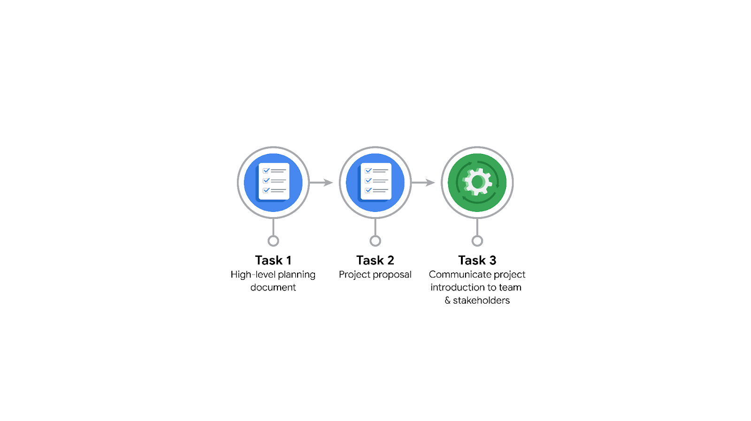

**Data Project Questions & Considerations**

**PACE: Plan Stage**

* Who is your audience for this project?

Waze Data team and cross functional teams.

* What are you trying to solve or accomplish? And, what do you anticipate the impact of this work will be on the larger needs of the client?

We are trying to reduce the churn rate of users. It will increase the growth of the application if we manage to retain the users. For this we aim to develop a machine learning model to predict user churn.

* What questions need to be asked or answered?

What variables will be more useful? What steps can be taken to reduce the impact of bias? Are there trends within the data that might be able to provide insights?

* What resources are required to complete this project?

Data sets, Python notebook/IDE, stakeholder input

* What are the deliverables that will need to be created over the course of this project?

Machine learning model that will accurately predict user churn.

## 

## **THE PACE WORKFLOW**

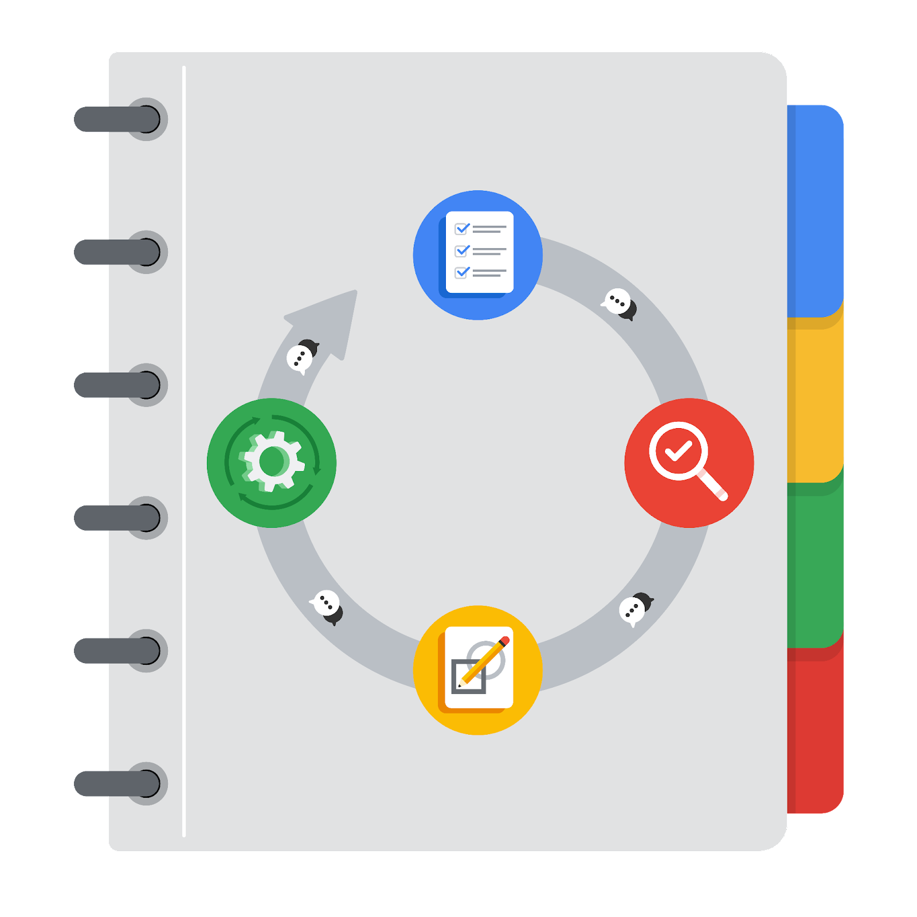

**[Alt-text: The PACE Workflow with the four stages in a circle: plan, analyze, construct, and execute.]**

You have been asked to demonstrate for the company's data team how you would use the PACE workflow to organize and classify tasks for the upcoming project. Select a PACE stage from the dropdown buttons. A few tasks involve more than one stage of the PACE workflow. Additionally, not every workplace scenario will require every task. Refer back to the Course 1 end-of-course portfolio project overview reading if you need more information about the tasks within the project.

### 

### **Project tasks**

Following are a group of tasks your company’s data team has determined need to be completed within this project. The data analysis manager has asked you to organize these tasks in preparation for the project proposal document. First, identify which stage of the PACE workflow each task would best fit under using the drop down menu. Next, give an explanation of why you selected the stage for each task. Review the following readings to help guide your selections and explanation: [The PACE stages](https://www.coursera.org/learn/foundations-of-data-science/supplement/4OtHr/the-pace-stages) and [Communicate objectives with a project proposal](https://www.coursera.org/learn/foundations-of-data-science/supplement/79Ysh/communicate-objectives-with-a-project-proposal). You will later reorder these tasks within a project proposal.

1. **Evaluating the model:** Execute

Why did you select this stage for this task?

Because in the execute stage we get to evaluate the model that is created and then put it to use to see whether we can reduce user churn rate. This allows us to make sure that the model is functioning properly.

1. **Conduct hypothesis testing:** Analyze **and** Construct

Why did you select these stages for this task?

During this stage, we can determine that a statistical test will be used and during the construction phase this test will then be carried out.

1. **Begin exploring the data:** Analyze

Why did you select this stage for this task?

Gives us an opportunity to explore the data and analyze it to see if there are any trends or patterns providing us a deeper understanding of the data set and its information.

1. **Data exploration and cleaning:** Plan **and** Analyze

Why did you select these stages for this task?

So that we can plan the methods that would be required here by exploring the data and during the analyze stage we can conduct the cleaning process for the data set.

1. **Establish structure for project workflow (PACE):** Plan

Why did you select this stage for this task?

This is essentially the planning stage to create the initial project PACE document which outlines the workflow and how to approach this project.

1. **Communicate final insights with stakeholders:** Execute

Why did you select this stage for this task?

After the model has been created the data has been explored and insights have been gained, we use this stage to communicate with the stakeholders to share these findings to take action.

1. **Compute descriptive statistics:** Analyze

Why did you select this stage for this task?

Investigating the statistics within data takes place during analysis.

1. **Visualization building:** Analyze **and** Construct

Why did you select these stages for this task?

Visualization happens with the data assessment and is then created during the construction phase.

1. **Write a project proposal:** Plan

Why did you select this stage for this task?

Plan a hypothesis or project proposal in this phase.

1. **Build a regression model:** Analyze **and** Construct

Why did you select this stage for this task?

**During the analyze stage we examine the model to make sure it will meet the needs of the task. Building the model will take place in the construction phase.**

1. **Compile summary information about the data:** Analyze

Why did you select this stage for this task?

Inspecting the data and compiling the information for the data.

1. **Build machine learning model:** Construct

Why did you select this stage for this task?

**Building a machine learning model in this phase.**